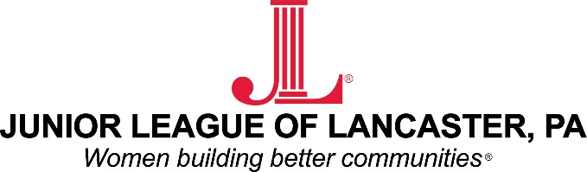

Contacts: Erica Croce/Randeen Orner/Meg Lefever Titter
Junior League of Lancaster 1130 Marietta Avenue
Lancaster, Pennsylvania 17603
Email: jllpublicrelations@gmail.com

FOR IMMEDIATE RELEASE: The Junior League of Lancaster receives award at the North Museum’s STEM SISTERS program.

LANCASTER, PA: The Junior League of Lancaster (JLL) accepted one of two Community Partner Awards on August 12th from the North Museum of Lancaster. "The JLL is genuinely honored to receive this award from the North Museum, and to be regarded as an effective and valuable community partner in Lancaster. As Girls + STEM is one of our key Issue-based Community Impact focus areas, we are proud to have joined forces with the North Museum to support its STEM Sisters program through voluntarism - together, we are empowering young women through the Museum's offerings to access, explore, and ignite their passions for STEM." Said JLL President Ann Carter.

JLL is seeking to recruit its next generation of women to take the organization to a new level of awareness, collaboration, and success. What better place to start than with the STEM Sister Program. One of the JLL’s two key impact areas; girls in science, technology, engineering, and mathematics (STEM) fields is a program that provides opportunities for girls and young women to explore and investigate educational opportunities often overlooked or underserved to the female population.

Upcoming events at the North Museum include the Discovery Dinner on October 16th- where STEM Sisters kick-off the new school year with an evening bringing girls and their parents together with female STEM professionals for dinner followed by STEM discussions, experiments and activities. For more information on the STEM Sisters Program, contact pampautz@northmuseum.org or help the Junior League support this and other community programs- attend the New Member Information Session on August 25th at the Mean Cup from 10:30-11:30 AM.
###

ABOUT THE JUNIOR LEAGUE OF LANCASTER: Established in 1923, the Junior League of Lancaster focuses on elevating the lives of women and children through education. Through our Projects and Programs, using our financial resources and trained volunteers we initiate and participate in community-based collaborative partnerships that work to broaden the educational, cultural, recreational and health opportunities for children in the Lancaster community. The
Junior League of Lancaster reaches out to all women who demonstrate an interest in and a commitment to voluntarism. This women’s organization is a 501(c)(3) and empowers members through leadership training as well as working together to build a better community. A prospective member must be at least 21 years of age.

MISSION: The Junior League of Lancaster is an organization of women committed to promoting voluntarism, developing the potential of women and improving communities through the effective action and leadership of trained volunteers. Its purpose is exclusively educational and charitable.

# # #

Please visit the League’s website at www.jllancaster.org for more information about the League’s projects, programs and fundraisers.

