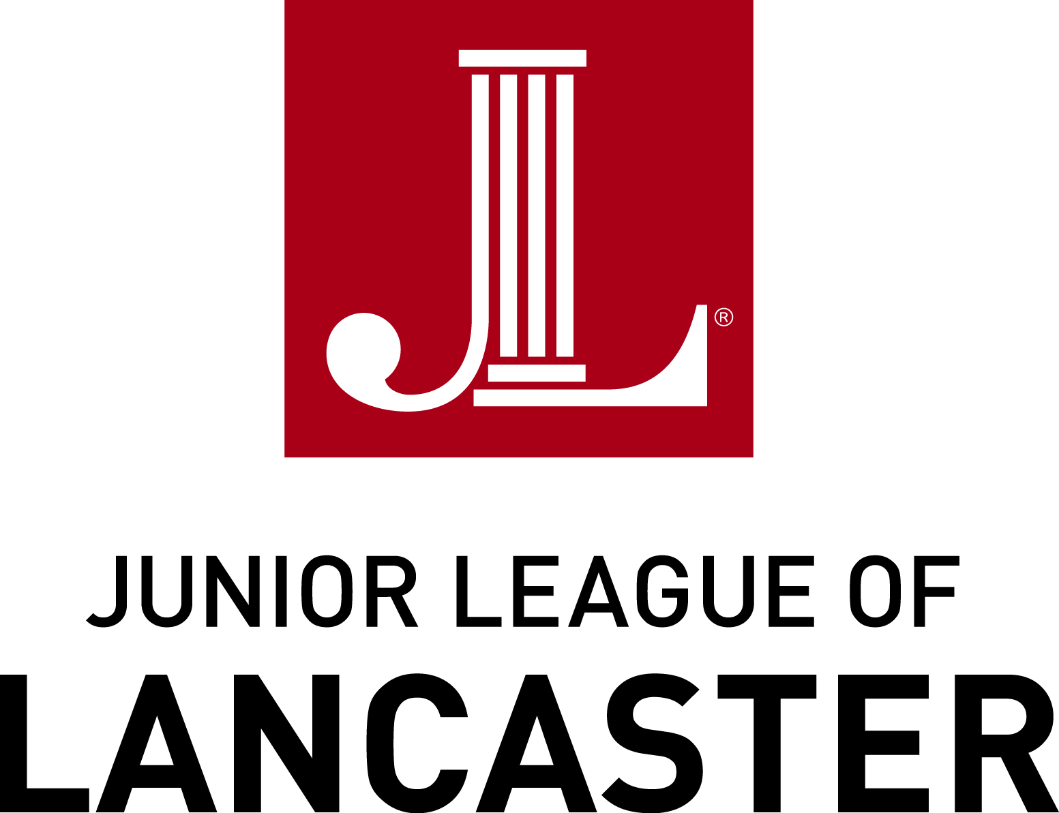

FOR IMMEDIATE RELEASE

Contact: Randeen Orner / Meg Lefever-Titter
Email: publicrelations@jllancaster.org
Junior League of Lancaster, PA, Inc.
1130 Marietta Avenue
Lancaster, Pennsylvania 17603

JUNIOR LEAGUE OF LANCASTER ANNOUNCES
2016-2017 PRESIDENT AND BOARD OF DIRECTORS

LANCASTER, PA (September 19, 2016) – The Junior League of Lancaster, PA, Inc. (JLL) is pleased to announce its new President – Ann Carter, and its 2016-2017 Board of Directors. Ann became the fourth member of her family to join the Junior League when she entered in 1999 in Lynchburg, VA; she transferred her membership from there to the Junior League of Norfolk-Virginia Beach, VA in 2006, and then to the Junior League of Lancaster in 2010. Ann has enjoyed a meaningful career of voluntarism in the Junior League; having dutifully chaired 7 different committees over her tenure, she now embarks upon her 6th year as a dedicated member of Junior League Boards.

As she begins her next leadership role, Ann shared the following comments:

“The woman who joins the Junior League is making a proactive investment in self and community: as she aligns herself locally with likeminded women who wish to develop themselves as civic leaders through community service and voluntarism, she also merges into an empowered female network of 291 Leagues in 4 countries, totaling more than 150,000 volunteers who are united in affecting positive, sustainable community impact on an international scale. It is a powerful and conscientious decision that a woman makes when she joins the Junior League; I am proud to have made that important decision 17 years ago, and am deeply honored to serve the Lancaster community and the JLL in this way.

The JLL is an organization of women that MAKES things happen. We plan strategically, and that process pushes forward our vision for mission-driven impact so we are always, in part, thinking in the future tense. Because of this, our Issue Based Community Impact focus areas – “Girls + STEM (Science, Technology, Engineering and Math)” and “Children Aging Out of Foster Care” – are thriving with new community partnerships, and innovative efforts to ensure that young women are inspired to pursue STEM freely, and that children who are in desperate need of a sense of family and support, know that someone in their community truly believes in them and wants them to succeed.”

The JLL is an organization of women committed to promoting voluntarism, developing the potential of women and improving communities through the effective action and leadership of trained volunteers. The JLL hosts various fundraisers which enable the group to support its community projects and programs.

On Friday, December 2, 2016, the League will host its annual Author’s Luncheon at Lancaster Penn Square Marriott featuring NY Times Best Selling Author, Laura Schroff, author of an Invisible Thread. For more information about this event and to register now, visit the JLL website at http://jllancaster.org/authors-luncheon/. On Saturday, March 11, 2017, the JLL will hold its 12th Annual “Run 4 Luck” 4K run/walk – a fun, St. Patrick’s Day-themed race day fit for families, walkers, and runners alike.

Please visit www.jllancaster.org for more information about these and other projects, programs, and fundraisers, or to become a member.

Photo Attached: JLL 2016-2017 Board of Directors

Front row, l-r: Beth Valentin, Recording Secretary; Ann Cater, President; Sarah Ganse, President
Elect; Nicole Clair, Nominating Chair.

Back row, l-r: Angela Ward, Parliamentarian; Kate Mullen, Placement Chair; Samantha Besnoff, Treasure; Carolyn Witwer, VP Membership Development; Libby Roman, VP Community Impact; Carol Graham, Sustainer Board Chair and Past President; Erica Croce, VP Communications; Debi Chen-Sloan, VP Fund Development.

###

ABOUT THE JUNIOR LEAGUE OF LANCASTER: Established in 1923, the JLL focuses on elevating the lives of women and children through education. Through our Projects and Programs, using our financial resources and trained volunteers we initiate and participate in community-based collaborative partnerships that work to broaden the educational, cultural, recreational and health opportunities for children in the Lancaster community. The JLL reaches out to all women who demonstrate an interest in and a commitment to voluntarism. This women’s organization is a 501(c)(3) and empowers members through leadership training as well as working together to build a better community. A prospective member must be at least 21 years of age.

MISSION: The JLL is an organization of women committed to promoting voluntarism, developing the potential of women and improving communities through the effective action and leadership of trained volunteers. Its purpose is exclusively educational and charitable.

