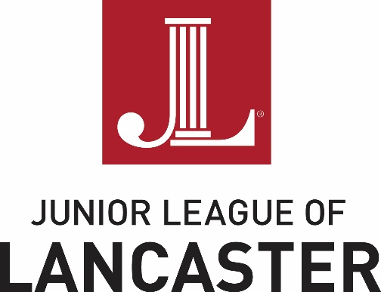

FOR IMMEDIATE RELEASE

Contact: Randeen Orner / Meg Lefever-Titter
Email: publicrelations@jllancaster.org
Junior League of Lancaster, PA, Inc.
1130 Marietta Avenue
Lancaster, Pennsylvania 17603

JUNIOR LEAGUE OF LANCASTER ANNOUNCES
the 2016 Author's Luncheon featuring Laura Schroff

LANCASTER, PA –The Junior League of Lancaster proudly welcomes Laura Schroff, author of the #1 New York Times and international bestseller An Invisible Thread, to the 2016 Author's Luncheon!

The event will include lunch, a presentation by the author, book signing opportunities, raffle items, a silent auction and cash bar.

Date: Friday December 2, 2016

Location: Marriott at Penn Square 25 S Queen St. Lancaster Pa. 17603

Time: Doors open at 11:00am

Tickets: $60 www.jllancaster.org/authors-luncheon

Laura Schroff is an international bestselling author and keynote speaker. Laura has spoken at over 150 events across the country and is dedicated to sharing her story on the power of small acts of kindness and the importance of seizing opportunities to make a difference in the lives of others.
An Invisible Thread is the true story of the bond between a harried sales executive and an eleven-year-old boy who seemed destined for a life of poverty. It is the heartwarming story of a friendship that has spanned three decades and brought meaning to an over-scheduled professional and hope to a hungry and desperate boy living on the streets.

The Community Awareness for An Invisible Thread
The community awareness and focus areas for the 2016 Author’s Luncheon are childhood hunger, homelessness and the importance of random acts of kindness.
- Aging Out of Foster Care:
In late 2014, the Junior League of Lancaster adopted the Issue-Based Community Impact Model to help effectuate long-lasting community change, and identified young people aging out of foster care as one issue to address. The JLL Aging Out of Foster Care Committee will be present at the Author’s Luncheon and invites all attendees to stop at their table to learn more about the issues these young people face. An interactive string maze will highlight the roadblocks that kids aging out of the foster care system face. There are approximately 600 children in foster care in Lancaster County, and approximately 45% of those children are teenagers. Each year, a number of them reach their 18th birthdays and graduate from high school while in the foster care system. These teenagers often lack the support and resources that young adults need to live independently and avoid a life of poverty and crime.

- Childhood Hunger:
Inspired by An Invisible Thread, students at JLL Cornerstone Sponsors Lancaster Country Day School and Linden Hall are working on service learning projects in conjunction with the Junior League to support Power Packs. Power Packs is a local organization dedicated to empowering food-insecure families to provide healthy meals so that children come to school well-fed and ready to learn. By providing a weekly pack filled with a recipe and ingredients to make a healthy meal and staples to help families get through the weekend, Power Packs works to make sure that every family has nutritious and economical food when the school breakfast and lunch programs are unavailable.

Students at Lancaster Country Day School and Linden Hall are conducting a protein food drive and a utensil drive to benefit Power Packs. Utensil items collected, such as colanders, measuring cups, measuring spoons, and other basic kitchen tools will help Power Packs families prepare nutritious meals.

The JLL is an organization of women committed to promoting voluntarism, developing the potential of women and improving communities through the effective action and leadership of trained volunteers. Proceeds from the 2016 Author’s Luncheon will enable the JLL to support its community projects and programs.

Please visit www.jllancaster.org for more information about these and other projects, programs, and fundraisers, or to become a member.

#

ABOUT THE JUNIOR LEAGUE OF LANCASTER: Established in 1923, the JLL focuses on elevating the lives of women and children through education. Through our Projects and Programs, using our financial resources and trained volunteers we initiate and participate in community-based collaborative partnerships that work to broaden the educational, cultural, recreational and health opportunities for children in the Lancaster community. The JLL reaches out to all women who demonstrate an interest in and a commitment to voluntarism. This women’s organization is a 501(c)(3) and empowers members through leadership training as well as working together to build a better community. A prospective member must be at least 21 years of age.

MISSION: The JLL is an organization of women committed to promoting voluntarism, developing the potential of women and improving communities through the effective action and leadership of trained volunteers. Its purpose is exclusively educational and charitable.

