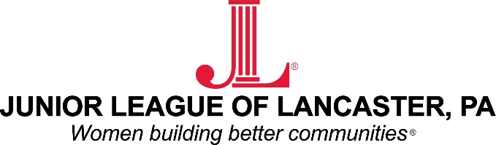

Contact: Christina Gallagher/ Sarah Ganse
Junior League of Lancaster 1130 Marietta Avenue
Lancaster, Pennsylvania 17603
Email: jllpublicrelations@gmail.com

FOR IMMEDIATE RELEASE: The Junior League of Lancaster receives $10,000 grant from Lancaster County Community Foundation

LANCASTER, PA: The Junior League of Lancaster (JLL) recently won a $10,000 capacity building grant from the Lancaster County Community Foundation (LCCF). Criteria for the LCCF capacity building grant required JLL to address its vision, organizational sustainability, need, and implementation plan. This capacity building grant will help JLL build its capacity to fulfill its mission – an organization of women committed to promoting voluntarism, developing the potential of women and improving the community through the effective action and leadership of trained volunteers; its purpose is exclusively educational and charitable.

JLL is seeking to recruit its next generation of women to take the organization to a new level of awareness, collaboration, and success. JLL’s goal is to increase community awareness about an organization that does so much for the Lancaster community and its people. The funds provided by LCCF will help JLL expand its membership, projects, and community impact in Lancaster.

JLL is now rolling out initiatives in two key impact areas of children aging out of foster care and girls in science, technology, engineering, and mathematics (STEM) fields. The Junior League of Lancaster pursued LCCF’s capacity building grant to hire a consultant to develop a marketing plan for the non-profit organization. The end goal for this consultant will be to develop JLL’s marketing plan leading to increased JLL membership to reach further into the community to address the issues facing the 1,000 children who have aged out of foster care in Lancaster County within the past 5 years and to expose the approximate 32,000 girls enrolled in Lancaster county public school districts to STEM.
JLL has shifted its focus to work on causes its members feel are important – areas largely underserved in the community that require a focused approach by a multitalented and diverse group of women and organizations. Through its new initiatives, JLL is now at a point of critical growth in the community and needs more volunteers and organizations to be attracted to join and collaborate.

At its core, JLL is driven by women committed to its mission and to increased community impact. Through the expertise of an outside consultant, JLL can better fulfill its highly-motivated mission in the Lancaster community. JLL is very excited by the award from LCCF and is looking forward to building its capacity to better serve Lancaster.
###

ABOUT THE JUNIOR LEAGUE OF LANCASTER: Established in 1923, the Junior League of Lancaster focuses on elevating the lives of women and children through education. Through our Projects and Programs, using our financial resources and trained volunteers we initiate and participate in community-based collaborative partnerships that work to broaden the educational, cultural, recreational and health opportunities for children in the Lancaster community. The
Junior League of Lancaster reaches out to all women who demonstrate an interest in and a commitment to voluntarism. This women’s organization is a 501(c)(3) and empowers members through leadership training as well as working together to build a better community. A prospective member must be at least 21 years of age.

MISSION: The Junior League of Lancaster is an organization of women committed to promoting voluntarism, developing the potential of women and improving communities through the effective action and leadership of trained volunteers. Its purpose is exclusively educational and charitable.

# # #

Please visit the League’s website at www.jllancaster.org for more information about the League’s projects, programs and fundraisers.

