Contact: FOR IMMEDIATE RELEASE
Meredith Baxter/Christine Gerben
Junior League of Lancaster 1130 Marietta Avenue Lancaster, Pennsylvania 17603 Email: jllpublicrelations@gmail.com

THE JUNIOR LEAGUE OF LANCASTER ANNOUNCES GIRLS IN BUSINESS COMPETITION WINNERS

LANCASTER, PA (May 1, 2015) – The Junior League of Lancaster, PA, Inc. (JLL) held its fourth annual Girls in Business competition on Saturday, April 11, 2015 at the Hamilton Club in Lancaster, Pennsylvania. Girls in Business is a business plan competition for high school girls in Lancaster County designed to identify and provide guidance to students who demonstrate initiative as entrepreneurs. Girls work closely with volunteer mentors to create a business plan for an original product or service. The program consists of the submission of a written business plan and an oral presentation to JLL members, mentors and local businesspeople.

The JLL is pleased to announce this year’s winners and business plan topics. Monetary awards for first, second and third place winners are $1,000, $500 and $250, respectively. First place was awarded to Feyi Makinde, whose business plan “Intercore Global Consulting” focused on providing accessible language and culture education services to meet the demands of the modern global market.

1st Place – “Intercore Global Consulting”
Oluwafeyikemi (Feyi) Makinde, Linden Hall; Melissa Golden, mentor

2nd Place – “Quiver” archery apparel
McKenna Kimmel, Lampeter-Strasburg High School; Kimberly Veirs, mentor

3rd Place – “Alter-E” personalized clothing alternations
Ileen Smith, Columbia High School; Michelle Dickinson, mentor

###

ABOUT THE JUNIOR LEAGUE OF LANCASTER: Established in 1923, the JLL focuses on elevating the lives of women and children through education. Through our Projects and Programs, using our financial resources and trained volunteers, we initiate and participate in community-based collaborative partnerships that work to broaden the educational, cultural, recreational and health opportunities for children in the Lancaster community. The JLL reaches out to all women who demonstrate an interest in and a commitment to voluntarism. This women’s organization is a 501(c)(3) and empowers members through leadership training as well as working together to build a better community. A prospective member must be at least 21 years of age.

MISSION: The JLL is an organization of women committed to promoting voluntarism, developing the potential of women and improving communities through the effective action and leadership of trained volunteers. Its purpose is exclusively educational and charitable.

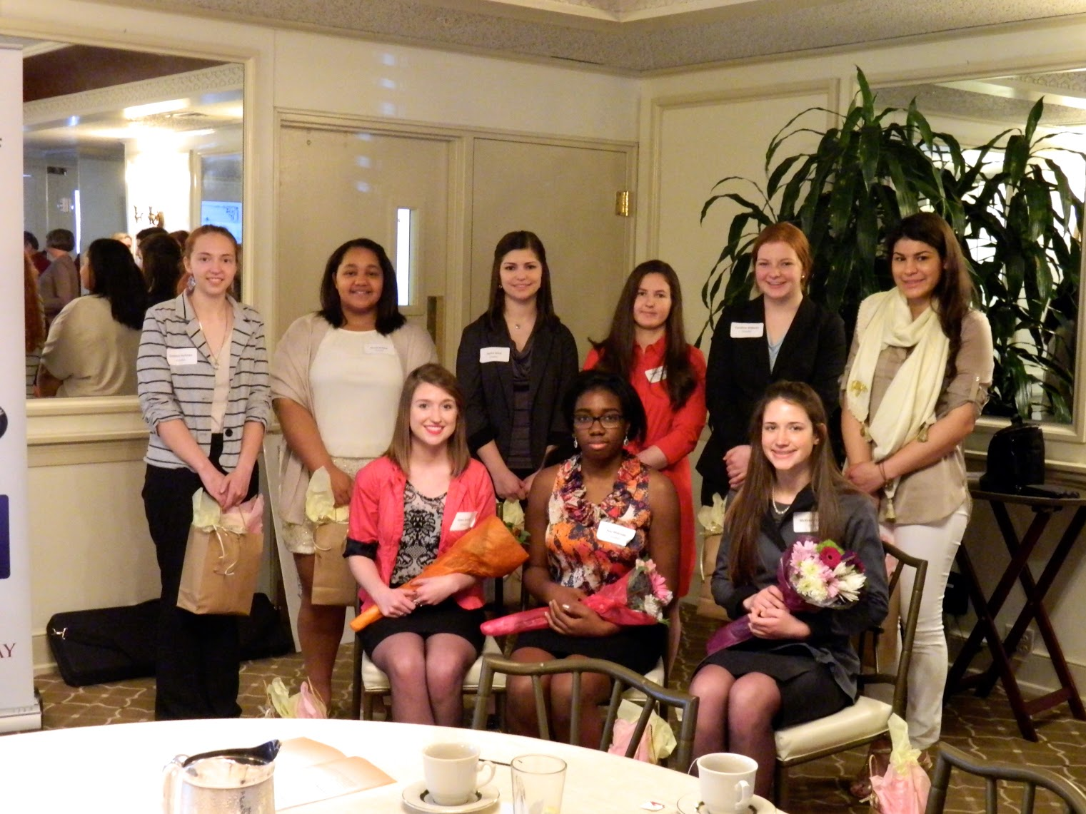

Girls in Business business plan competition finalists at the Hamilton Club on April 11, 2015. Back row (left-to-right): Gretchen Hartman, Nicole Riddick, Caroline Willems, Samantha Kapushy, Jessica Horst and Nicole Beidelman.
Front row (left-to-right): Ileen Smith (3rd place), Feyi Makinde (1st place) and McKenna Kimmel (2nd place)

