Contact: Meredith Baxter/Christine Gerben FOR IMMEDIATE RELEASE
Junior League of Lancaster, PA, Inc. 1130 Marietta Avenue Lancaster, Pennsylvania 17603 Email: jllpublicrelations@gmail.com

“FEED THE NEED” EXCEEDS GOAL:
3004 POUNDS OF FOOD DONATED TO WATER STREET MISSION

HARTZ PHYSICAL THERAPY AND JUNIOR LEAGUE OF LANCASTER
“FEED THE NEED” DRIVE DONATES 1.502 TONS OF FOOD
TO BENEFIT WATER STREET MISSION

LANCASTER, PA (May 8, 2015) – The April 2015 HARTZ Physical Therapy and Junior League of Lancaster, PA (JLL) “Feed the Need” food donation drive benefitting Water Street Mission (WSM) programs exceeded its 250-pound goal, and donated a grand total of 3004 pounds – or 1.502 tons – of non-perishable food to WSM. Donations were received from the community at HARTZ PT offices, and managed by its staff and JLL volunteers; the food will be used to serve free meals and provide free pantry items to Lancaster County men, women, and children in need at WSM.

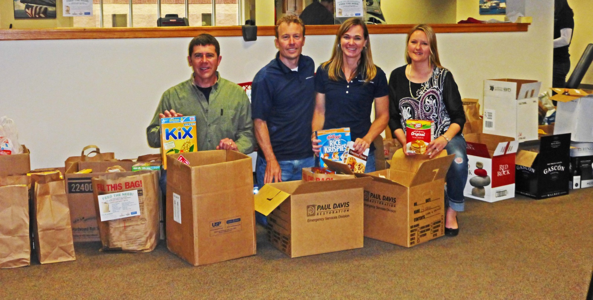
(Left to right: WSM Director of Donor Relations Keith Shetter, HARTZ Physical Therapy’s Dr. Brian Hartz,
JLL President Amy Hartz, and JLL Fund Development Assistant VP and President-Elect-Elect Ann Carter)

## NEXT PAGE ##

The JLL and HARTZ Physical Therapy (each found online at www.jllancaster.org and www.hartzpt.com) are community partners this year as a result of HARTZ PT’s Cornerstone Sponsorship of the League, which will help further its 90-year-old mission of developing the potential of women while promoting voluntarism, and positively impacting the community through the trained, effective action of its volunteers.

Since 1905, Water Street Mission (found online at www.wsm.org) has served Lancaster County homeless and hungry men, women, and children with the goal to provide comprehensive support to those in the traumatic crisis of homelessness. WSM facilitates life change by providing stable shelter, three meals a day, and connecting guests with: behavioral health support through Christian counseling, medical and dental care, and career support services. It serves free meals to approximately 500 people each day, and offers free pantry items to close to 700 people per week.

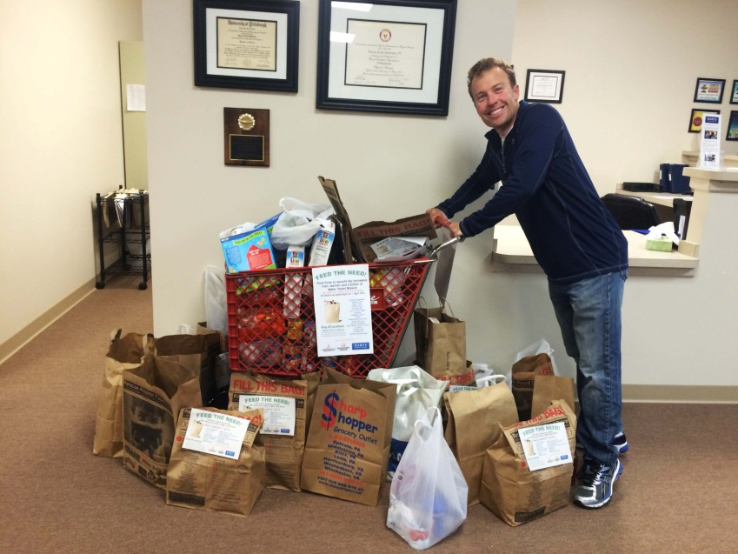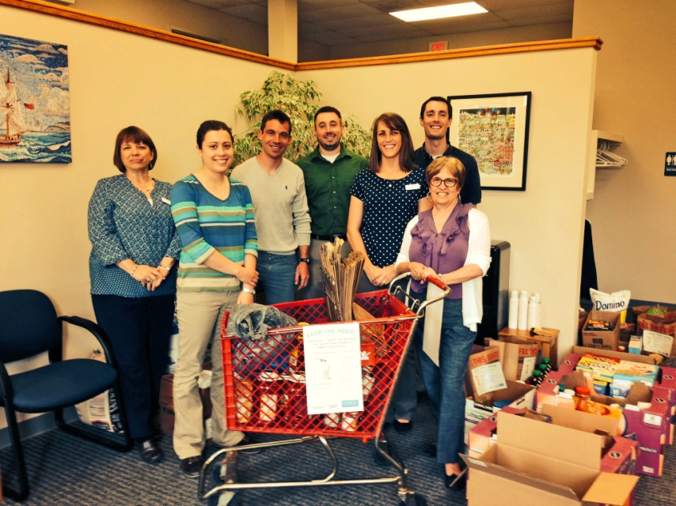
(Left: Dr. Brian Hartz with donations at his Ephrata office.
Right: HARTZ Physical Therapy Lititz office staff surrounded by donations.)

## NEXT PAGE ##

HARTZ Physical Therapy has served Lancaster County as an outpatient provider of physical therapy services for 15 years. An independently owned small business, HARTZ PT specializes in providing quality personalized care to its patients at each of its three locations in Lititz, Lancaster and Ephrata. Community-minded from the beginning, the staff of HARTZ PT is always open to partnering with community organizations in creative ways with the goal of improving the community one step at a time.

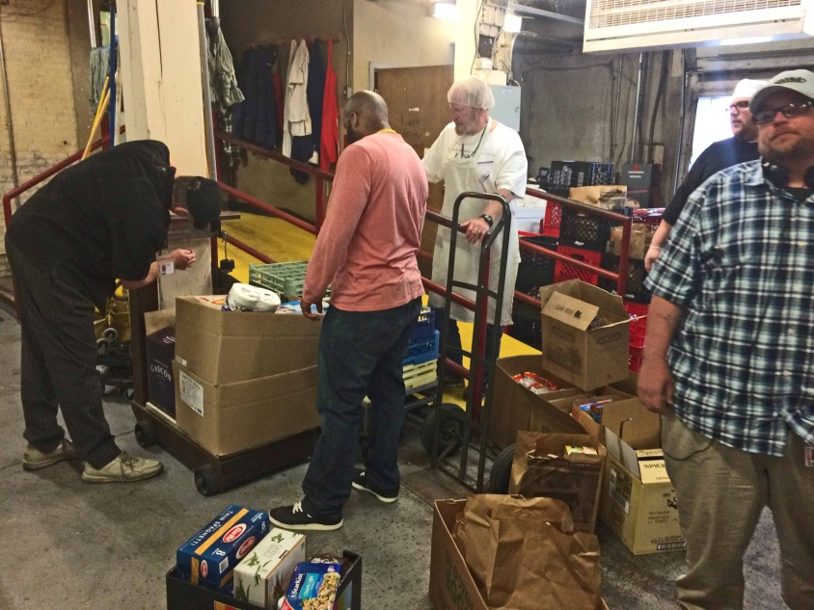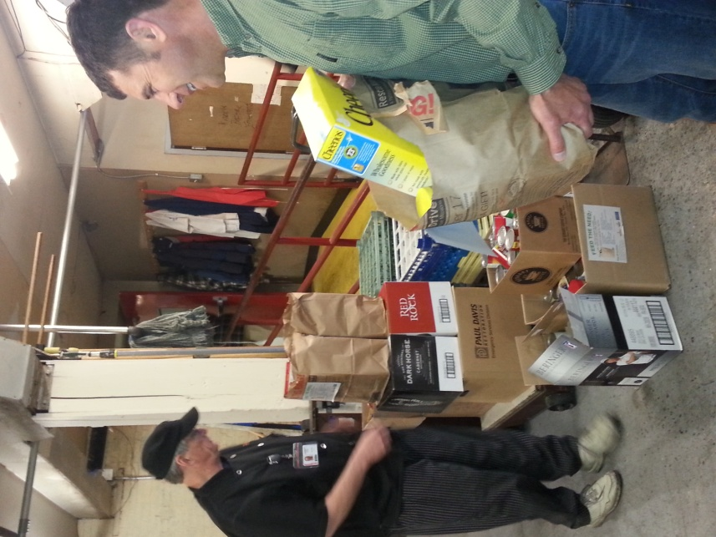
(Left and right: Water Street Mission staff loading in and weighing “Feed the Need” donations.)

***

ABOUT THE JUNIOR LEAGUE OF LANCASTER: Established in 1923, the JLL focuses on elevating the lives of women and children through education. Through our Projects and Programs, using our financial resources and trained volunteers we initiate and participate in community-based collaborative partnerships that work to broaden the educational, cultural, recreational, and health opportunities for children in the Lancaster community. The JLL reaches out to all women who demonstrate an interest in and a commitment to voluntarism. This women’s organization is a 501(c)(3) and empowers members through leadership training as well as working together to build a better community. A prospective member must be at least 21 years of age.

MISSION: The JLL is an organization of women committed to promoting voluntarism, developing the potential of women and improving communities through the effective action and leadership of trained volunteers. Its purpose is exclusively educational and charitable.

## END ##

