Contact: FOR IMMEDIATE RELEASE
Meredith Baxter/Christine Gerben
Junior League of Lancaster
1130 Marietta Avenue Lancaster, Pennsylvania 17603 Email: jllpublicrelations@gmail.com

THE JUNIOR LEAGUE OF LANCASTER ANNOUCES
THE DEBORAH P. ALTMAN OUTSTANDING YOUTH VOLUNTEER AWARD WINNERS

LANCASTER, PA (May 11, 2015) – The Junior League of Lancaster, PA, Inc. (JLL) is pleased to announce this year’s winners of the 2015 Deborah P. Altman Outstanding Youth Volunteer Award –Derick Weaver from Garden Spot High School, Madison Scull from Lancaster Country Day School and Erik Homberger from Warwick High School. The winners were invited guests at the JLL General Membership Meeting held on May 4, 2015 at LancasterHistory.org. Each student received a $600 prize of which $100 will be designated to a charity of their choosing. Donations will be made to Leukemia & Lymphoma Society (Weaver); The Campaign for Female Education (Scull), and the Hugh O’Brian Youth Leadership Organization (Homberger).

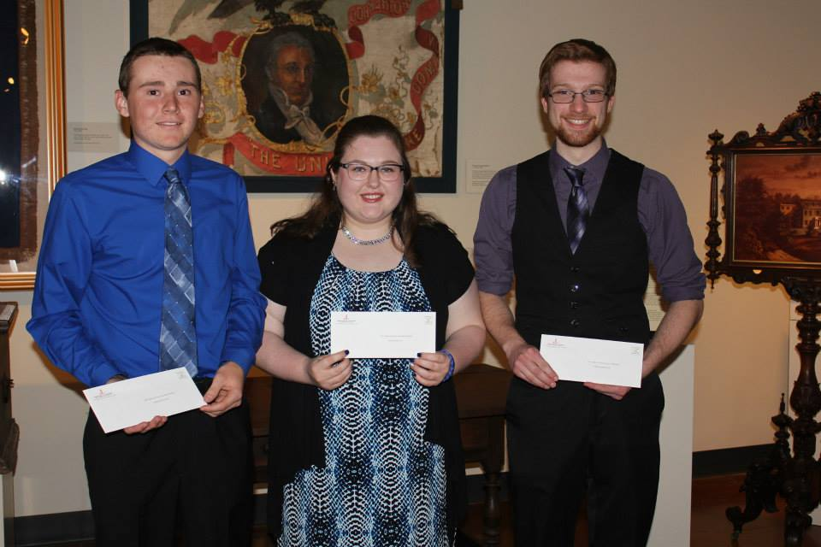
The award is named for Deborah P. Altman, past president of the Junior League of Lancaster whose life exemplified a commitment to volunteering, a love of children and service to the community. The purpose of the award is to recognize young people who demonstrate an exceptional interest and involvement in volunteerism as well as inspiring their peers to volunteer in their communities. Since the award was established in 1984, over $40,000 has been awarded to outstanding youths in Lancaster County.

2015 Deborah P. Altman Outstanding Youth Volunteer Award Winners at the May 4th, 2015 JLL General Membership Meeting at LancasterHistory.org. From left to right: Derick Weaver (Garden Spot), Madison Scull (LCDS), Erik Homberger (Warwick).

###

ABOUT THE JUNIOR LEAGUE OF LANCASTER: Established in 1923, the JLL focuses on elevating the lives of women and children through education. Through our Projects and Programs, using our financial resources and trained volunteers, we initiate and participate in community-based collaborative partnerships that work to broaden the educational, cultural, recreational and health opportunities for children in the Lancaster community. The JLL reaches out to all women who demonstrate an interest in and a commitment to voluntarism. This women’s organization is a 501(c)(3) and empowers members through leadership training as well as working together to build a better community. A prospective member must be at least 21 years of age.

MISSION: The JLL is an organization of women committed to promoting voluntarism, developing the potential of women and improving communities through the effective action and leadership of trained volunteers. Its purpose is exclusively educational and charitable.

